Bean life cycle in Java Spring
The lifecycle of any object means when & how it is born, how it behaves throughout its life, and when & how it dies.
Similarly, the bean life cycle refers to when & how the bean is instantiated, what action it performs until it lives, and when & how it is destroyed.
In this article, we will discuss the life cycle of the bean.
Bean life cycle is managed by the spring container. When we run the program then, first of all, the spring container gets started. After that, the container creates the instance of a bean as per the request, and then dependencies are injected. And finally, the bean is destroyed when the spring container is closed. Therefore, if we want to execute some code on the bean instantiation and just after closing the spring container, then we can write that code inside the custom init() method and the destroy() method.
The following image shows the process flow of the bean life cycle.
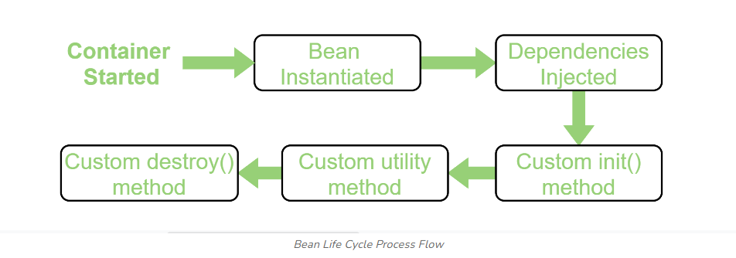

Note: We can choose a custom method name instead of init() and destroy(). Here, we will use init() method to execute all its code as the spring container starts up and the bean is instantiated, and destroy() method to execute all its code on closing the container.

